## User tutorial

In order to use the script, the user must have RStudio installed on its computer. If the user hasn’t done this yet, go to [The Comprehensive R Archive Network (r-project.org)](https://cran.r-project.org/) for the RStudio download link. A clear and easy to understand installation guide can be found at [Tutorial: Downloading and Installing R on Your Computer (dataquest.io)](https://www.dataquest.io/blog/installing-r-on-your-computer/).

When the user opened the Marketplace comparer script, the following screen (Figure 18) is displayed.

Figure 18 - Start screen

Only three steps must be taken in order to make use of this script, and with it, compare listings.

1. Fill in the search term at code line #29
   1. Make sure you only replace the green part of the code line
   2. Make sure you use quotation marks on both sides of the search term



Figure 19 - Only the "Nikon D610" must be replaced with the desired search term

1. Run the script by pressing “ctrl + alt + R”
   1. Or by clicking on the Run All button in the drop down menu (see Figure 20).

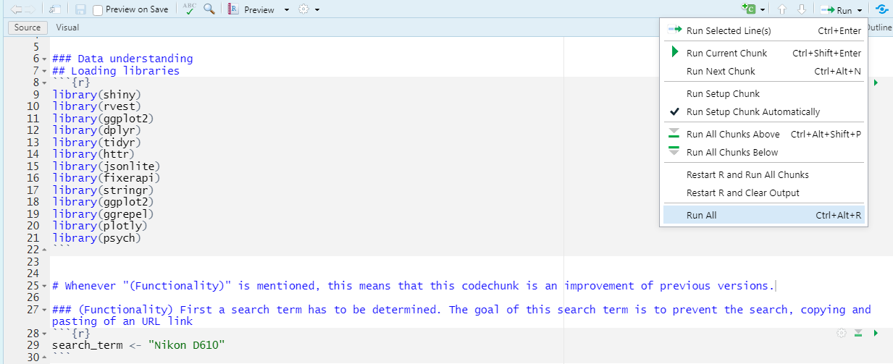

Figure 20 - Clicking on the Run All button

1. Interpret the result, the bar plot, of the script at the bottom of the script
   1. Figure 21 shows 2 horizontal lines. Based on the legend it can be said that the red line represents the lowest price of the Nikon D610 search term on eBay, the blue line does the same for Marktplaats. The difference indicates that there is an opportunity to make a profit out of it. This can be done by buying the cheapest product on eBay and thereafter sell it on Marktplaats for a higher price.

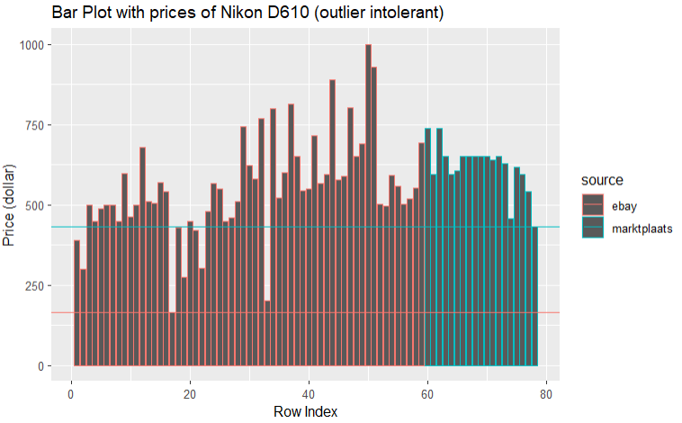

Figure 21 - Bar plot as result of the script

## Limitations

The current script has a couple of limitations The most important limitation is that the prices only shows the cost of a certain item. It does not say anything about the condition of the item. Therefore, the interpretation of the prices is susceptible to subjectivity. This means that the user of the script should judge itself if a certain item can be sold at a higher price.

A possible, not-yet existent, solution to make it easier to compare the conditions of these actual listings, is by making the bar graph interactive. In an ideal situation the user should be able to click on a certain bar in the bar plot, so that the user is redirected to the corresponding listing on its source page. However, the subjective interpretation of the condition and value of an item has not yet been taken away in this case.

In order to make it possible to compare listings in an objective way, a different approach should be designed. One of the potential solutions is to use the description of the condition of a listing on the source page, and give it a weighing factor. Which this factor a score can be created (for example a 0% to 100% lifespan score). Herewith it enables an user to objectively judge the condition of a certain item and therefore value it.